**Name :- Vraj Rana PRN no:- 2017033800104963**

**Practical 4**

1. **Write a program to find length of given n-byte and n-word arrays.**

.model small

.data

a db 10h,11h,12h,13h,14h

len_byte_array db $-a

b dw 1111h,1112h,1113h,1114h

c dw 1115h

len_word_array dw ?

d dw 0002h

.code

main proc near

mov ax,@data

mov ds,ax

lea ax,c

lea bx,b

sub ax,bx

mov bx,d

div bx

mov len_word_array,ax

mov ax,04ch

int 21h

endp

end

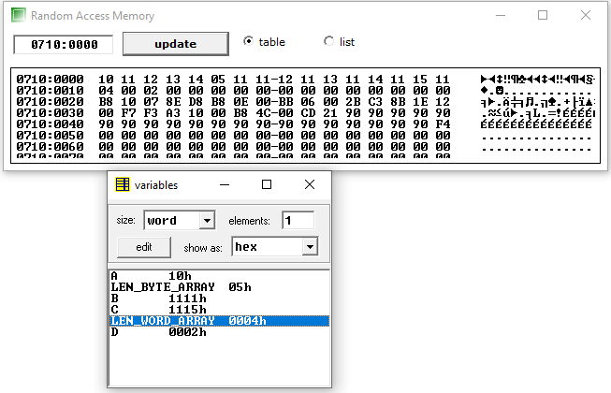

1. **Write a program to count the occurrences of a number in the given n-word array.**

.model small

.data

a dw 01h,02h,01h,03h,01h,04h,01h,05h,01h,01h

len dw $-a

o db 01h

count db ?

d dw 0002h

.code

main proc near

mov ax,@data

mov ds,ax

mov ax,len

div d

mov bl,o

lea si,a

mov cx,ax

l1:

mov al,[si]

cmp al,bl

jne skip

inc count

skip:

inc si

inc si

loop l1

mov ax,04ch

int 21h

endp

end

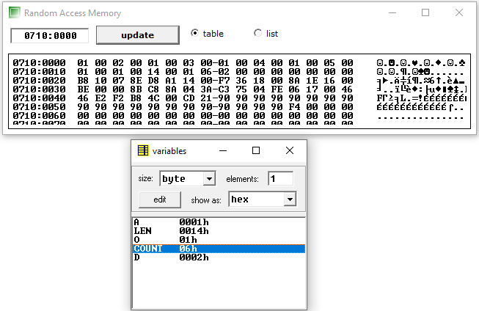

1. **Write a program to sort the given n-byte array in ascending order.**

.model small

.data

a db 06h,02h,05h,04h,03h,07h,01h,08h

len db $-a

c db 00h

c1 db 00h

c2 db 00h

c3 db 07h

r db 08 dup(?)

.code

main proc near

mov ax,@data

mov ds,ax

lea si,a

mov dl,len

mov dh,len

mov c,dl

mov cx,0000h

outer:

inc c2

mov bl,[si]

mov cl,len

iner:

mov al,[si]

cmp [si],bl

ja skip

xchg bl,[si]

skip:

inc si

loop iner

mov r+c3,bl

dec c3

xchg bl,[si]

lea si,a

inc si+c2

mov len,dh

mov dl,c

cmp dl,c1

je skip1

dec c

jmp outer

skip1:

mov ax,04ch

int 21h

endp

end

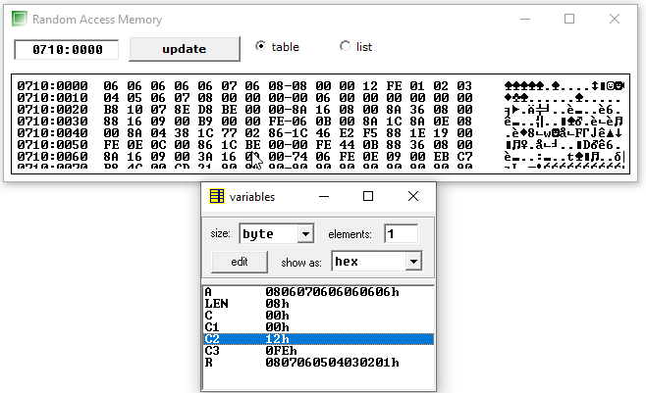

1. **Write a program to sort the given n-word array in ascending order.**

.model small

.data

a dw 1115h,1112h,1113h,1114h

len db $-a

c db 00h

c1 db 00h

c2 db 00h

c3 db 07h

r dw 03 dup(?)

.code

main proc near

mov ax,@data

mov ds,ax

mov ah,00h

mov al,len

mov bl,02h

div bx

mov len,al

lea si,a

mov dl,len

mov dh,len

mov c,dl

mov cx,0000h

outer:

inc c2

inc c2

mov bl,[si]

mov bh,[si+1]

mov cl,len

iner:

mov al,[si]

mov ah,[si+1]

cmp ax,bx

ja skip

xchg bl,[si]

xchg bh,[si+1]

skip:

inc si

inc si

loop iner

mov r+c3,bx

dec c3

dec c3

xchg bl,[si]

xchg bh,[si+1]

lea si,a

inc si+c2

mov len,dh

mov dl,c

cmp dl,c1

je skip1

dec c

jmp outer

skip1:

mov ax,04ch

int 21h

endp

end

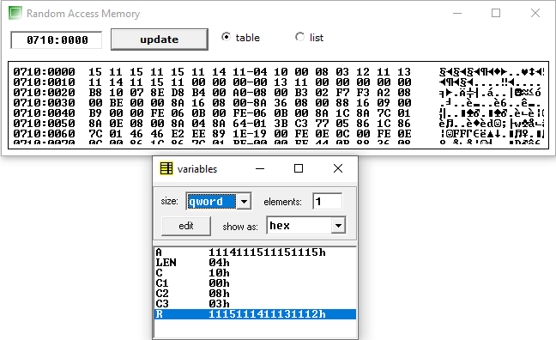

1. **Write a program to find X^Y for an 8-bit number.**

.model small

.data

a db 06h

b db 04h

c dw ?

.code

small proc near

mov ax,@data

mov ds,ax

dec b

mov cl,b

mov al,a

mov bl,a

loop1:

mul bl

loop loop1

mov c,ax

mov ax,04ch

int 21h

endp

end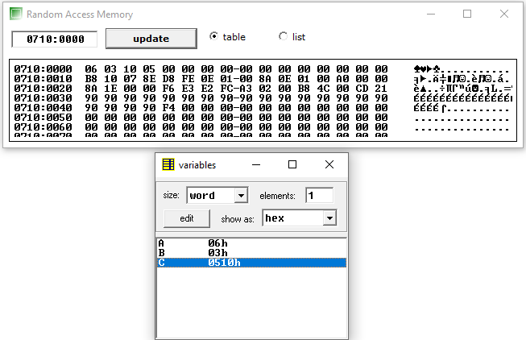

1. **Write a program to find cube of a word**.

.model small

.data

a dw 1111h

r1 dw 02 dup(?)

r dw 03 dup(?)

.code

main proc near

mov ax,@data

mov ds,ax

mov ax,a

mov bx,a

mul bx

mov r1+2,dx

mov r1,ax

mov ax,r1

mul bx

mov r,ax

mov cx,dx

mov ax,r1+2

mul bx

add ax,cx

mov r+2,ax

mov r+4,dx

mov ax,04ch

int 21h

endp

end

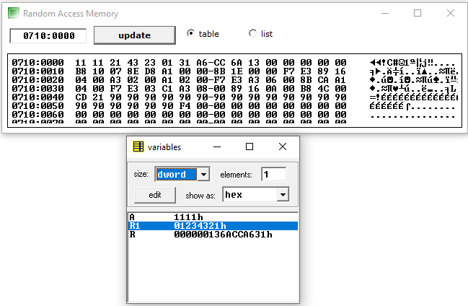

1. **Write a program to find factorial a given 8-bit number.**

.model small

.data

a dw 008h

b db 07h

c dw ?

.code

main proc near

mov ax,@data

mov ds,ax

mov ax,a

mov cl,b

l1:

mul cx

loop l1

mov c,ax

mov ax,04ch

int 21h

endp

end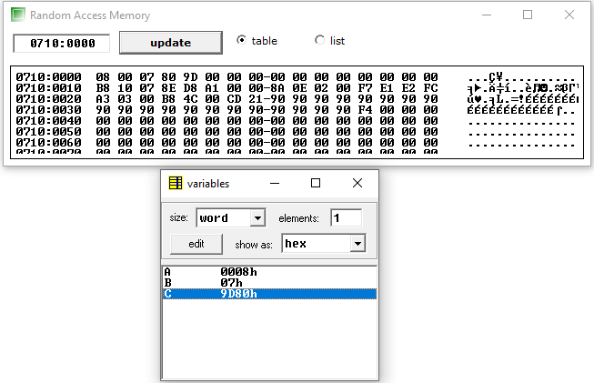

1. **Write a program to find LCM of two 16 bit numbers.**

.model small

.data

num1 dw 1500

num2 dw 2500

hcf dw ?

lcm dw ?

.code

main proc near

mov ax,@data

mov ds,ax

mov ax,num1

mov bx,num2

while:

mov dx,0

mov cx,bx

div bx

mov bx,dx

mov ax,cx

cmp bx,0

jne while

mov hcf,ax

mov cx,ax

mov ax,num1

mov bx,num2

mul bx

div cx

mov lcm,ax

mov ax,04ch

int 21h

endp

end

